**CSE102L Computer Programming Lab**

**LAB # 2**



**2020**

**Submitted to:**

**Engr. Abdullah Hamid**

**Submitted by:**

**TAYYABA**

**Registration No :**

**19PWCSE1854**

**Semester: 2nd**

**Class Section:** **C**

“On my honor, as student of University of Engineering and Technology,

I have neither given nor received unauthorized assistance on this

academic work.”

March 2 , 2020

**Department of Computer Systems Engineering**

**University of Engineering and Technology, Peshawar**

## **Objective:**

**To be familiar with different data types, Operators and Expressions in C++.**

## **Task # 1**

### **Title:**

Write a program that takes the temperature in Fahrenheit and convert it to Celsius and Kelvin:

K = C + 273

C = (F – 32) / 1.8

### **Code:**

# include < iostream>// library for writing the output to console window

using namespace std;

int main ()

{

float x,y;

cout<<"Enter Temperature in Faranhite = \n";

cin>>x;

cout<<"\n\n";

cout<<"Temperature in Celsius = "<< (x-32)/1.8;

cout<<"\n";

cout<<"Temperature in Kelvin = "<<((x-32)/1.8)+273;

}

**Output (Compilation, Debugging & Testing):**

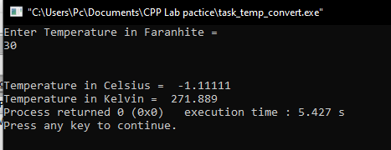

**Task # 2**

### **Title:**

Write the C++ code that takes the integer a, b, c, d and e from the user and display the output according to the following equation.

a3 + b2 – d / b

## a ( b + c ( e + a ) / b )- 10

**Code:**

#include <iostream>// library for writing the output to console window

using namespace std;

int main()

{

float a,b,c,d,e,k,m;

cout<<"Enter a = ";

cin>>a;

cout<<"\n";

cout<<"Enter b = ";

cin>>b;

cout<<"\n";

cout<<"Enter c = ";

cin>>c;

cout<<"\n";

cout<<"Enter d = ";

cin>>d;

cout<<"\n";

cout<<"Enter e = ";

cin>>e;

cout<<"\n";

k=((a*a*a)+(b*b)-d)/b;

m=a*(b+c*(e+a)/b)-10;

int answer =k/m ;

cout<<answer;

return 0;

}

**Output (Compilation, Debugging & Testing):**

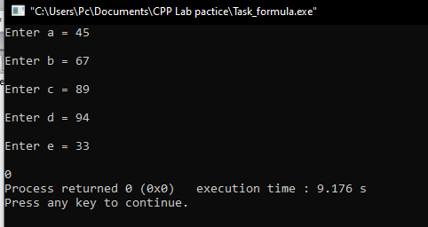

## **Task # 3:**

### **Title:**

Write a program to declare two integer and one float variables then initialize them to 10, 15, and 12.6. Also print the variable values in the screen

**Code:**

#include <iostream>>

using namespace std;

int main()

{

int x=10; ; //declare variable and assign value to variable

int y=15; ; //declare variable and assign value to variable

float z=12.6; ; //declare variable and assign value to variable

cout<<x<<endl; //display x

cout<<y<<endl; //display y

cout<<z<<endl; //display z

return 0;

}

**Output (Compilation, Debugging & Testing):**

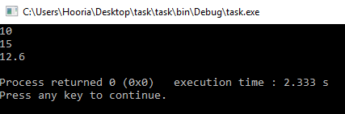

**Task # 4:**

**Title:**

Write a C++ program to prompt the user to input 3 integers values and print these values in forward and reversed order.

**Code**:

#include <iostream>

using namespace std;

int main()

{

int a,b,c; //variable declaration

cout<<"Enter a = ";

cin>>a;

cout<<"\n";

cout<<"Enter b = ";

cin>>b;

cout<<"\n\n";

cout<<"Enter c = ";

cin>>c;

cout<<"\n\n";

cout<<a<<b<<c;

cout<<"\n\n";

cout<<c<<b<<a;

return 0;

}

**Output (Compilation, Debugging & Testing):**

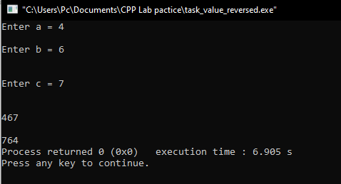

## **Task # 5:**

### **Title:**

Write a program to swap two variables values with and without using third variables.

Code:

**Code:**

Without Using 3rd Variable:

#include <iostream>

using namespace std;

int main()

{

float a,b;

cout<<"Enter a = ";

cin>>a;

cout<<"\n";

cout<<"Enter b = ";

cin>>b;

cout<<"\n\n";

cout<<"a"<<"="<<b;

cout<<"\n\n";

cout<<"b"<<"="<<a;

}

**Output (Compilation, Debugging & Testing):**

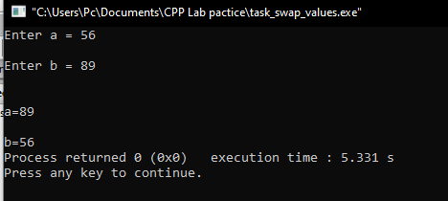

**With using 3rd variable:**

#include <iostream>

using namespace std;

int main()

{

int a,b,c;

cout <<"Enter 1st num:"; //user enters the value of 1st num

cin >>a;

cout <<"Enter 2nd num:"; //user enters the value of second num

cin >>b;

c=a; //c is equal to 1st num

a=b; //1st num is equal to 2nd num

b=c; //2nd num is qual to c

cout <<"value of 1st num"<<endl;

cout<<a<<endl; //display a

cout <<"value of 2nd num"<<endl;

cout <<b<<endl; //display b

return 0; //end the program }

**Output (Compilation, Debugging & Testing):**

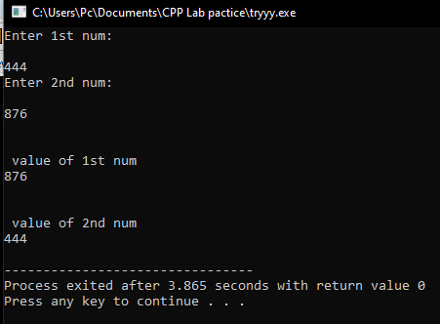

**TASK # 6:**

Write a program to print the size of char, float, double and long double data types in C.

**Code:**

#include <iostream> /* library for writing the output to console window*/

using namespace std;

int main()

{ //start the program

int a;

float b;

char c;

double d;

long double e;

cout<<"size of int = "<<sizeof(a);

cout<<"\n\n";

cout<<"size of float = "<<sizeof(b);

cout<<"\n\n";

cout<<"size of char = "<<sizeof(c);

cout<<"\n\n";

cout<<"size of double = "<<sizeof(d);

cout<<"\n\n";

cout<<"size of long double = "<<sizeof(e);

}

**Output (Compilation, Debugging & Testing;**